____________________________________________________________________________

Status of code / additional notes
Points / descriptions to check
Priority to check
Choice (to re-visit later or after writing code in full)
Checks
Code snippets

____________________________________________________________________________

START OF PROGRAM:

Imports:
- numpy
- os
- from preliminaries, SLN, CC3

Set values and load data:

- Set astrophysical parameter values, to match the values from 2201.01265
  - local_DM_GeV = 0.47685 0.4746 # DM local density in GeV/cm^3 Not necessary for calculating the GC constraint
  - r_0 = 8.5 # distance Sun-GC in kpc
  - rho_c_halo = 8.5e-25 # characteristic halo density in g/cm^3
  - r_c_halo = 17 # characteristic halo radius in kpc
  - gamma_halo = 1 # density profile inner slope

Comment:
- These astrophysical parameter values are from a comment on line 823 of isatis.c (unmodified version of Isatis).
- Notably, they do not include the local DM density.
- I have calculated the results and compared to Table II of 1102.4340 to ensure the values match those given above.

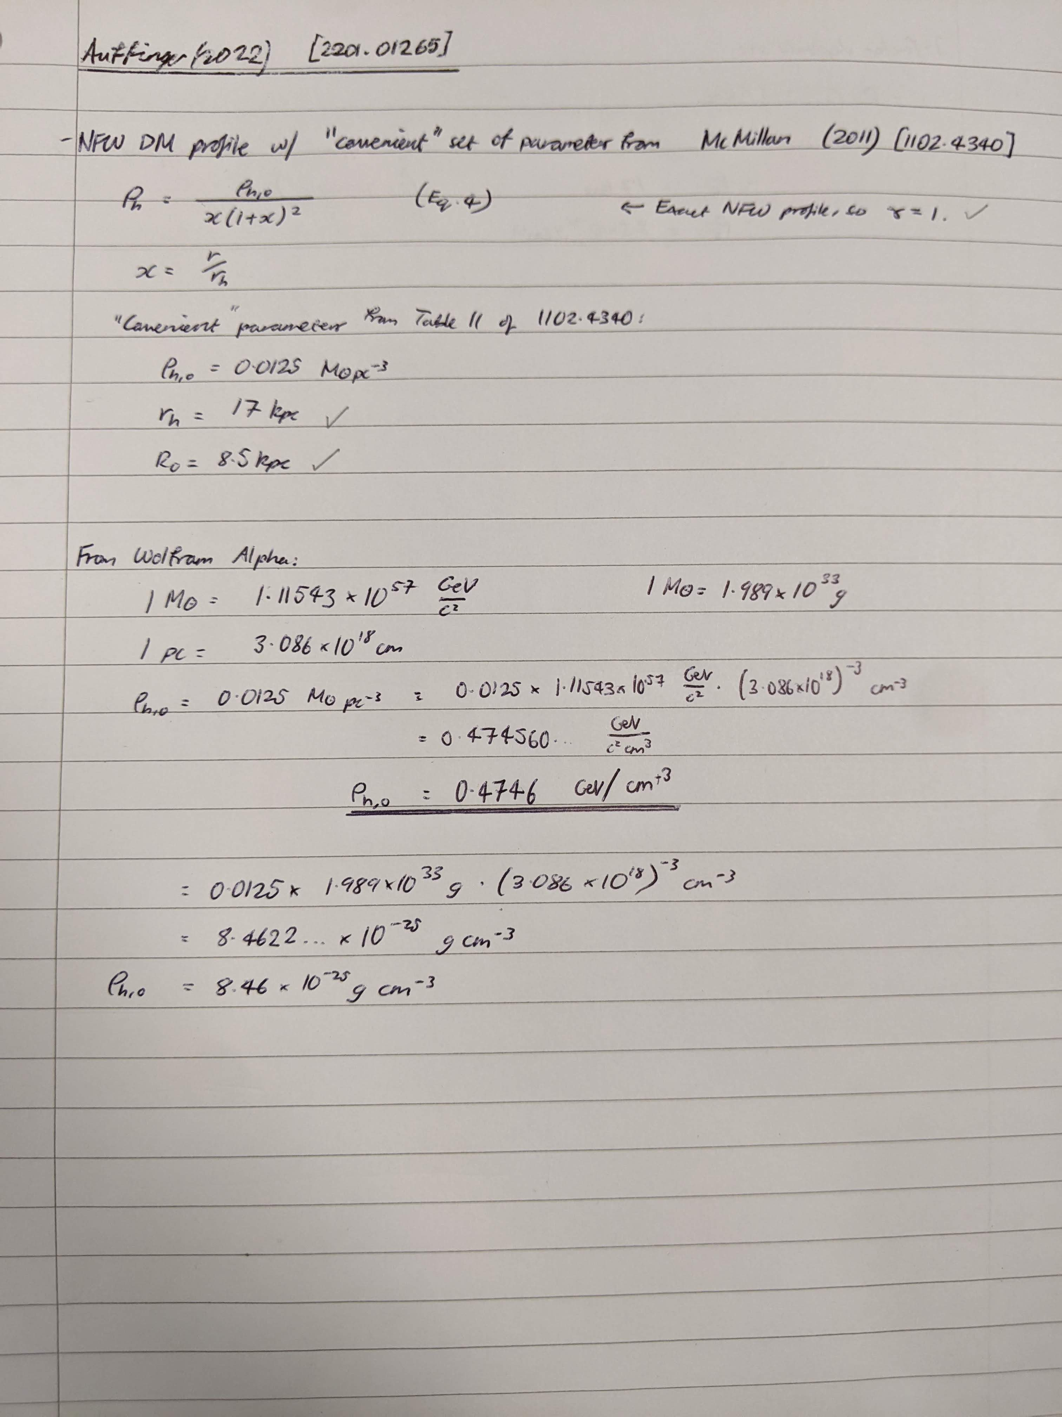

Quantities relevant for mass functions:

- Booleans control which mass function to use
- Load mass function parameters
- Set minimum and maximum characteristic PBH masses M_c
  - mc_min = 1e14g, mc_max = 1e19g
- Boolean to control whether to use a single characteristic PBH mass M_c
  - If True: mc_values = np.logspace(np.log10(mc_min), np.log10(mc_max), 100)
  - Else: mc_values = [mc_max]
- Boolean to control whether to use a range of PBH masses that matches those used in isatis_reproduction.py. Use for comparing to the results obtained using the method from 1705.05567.
- Load minimum and maximum scaled masses for which the MF is above a cutoff (calculated in preliminaries.py)
- Set (logarithmic) PBH mass spacing, in log10(PBH mass / grams)

Quantities relevant for running Isatis

- Set path to BlackHawk and Isatis
- Load default Isatis parameters file
- Load default BlackHawk parameters filename
- Set number of BHs to include Set mass spacing (in log(m)) between subsequent PBHs
  - BH_number = 10000 Calculate BH_number using the range and spacing
- Choose energy range to include in BlackHawk spectrum calculations
  - E_min = 1e-5 (lower range constrained by the Galactic Centre photon flux measured by INTEGRAL, COMPTEL, EGRET and Fermi-LAT (see e.g. Fig. 2 of 2201.01265))
  - E_max = 5 (maximum energy available in Hazma tables)
  - E_number = 1000 Decide whether to perform a convergence test for this as well
- Set initial line of the BH spectrum file (relevant for SLN and CC3 MFs)
  - spec_file_initial_line = "mass/spin \t 0.00000e+00"

Input for when running BlackHawk
# Write your input when running BlackHawk to a file
with open(BlackHawk_path + "input.txt", "w") as f:
f.write("y\ny")
# Update astrophysical parameter values used in Isatis
parameters_Isatis[2][1] = "0"
parameters_Isatis[3][1] = "{:.2f}".format(local_DM_GeV)
parameters_Isatis[5][1] = "{:.2f}".format(r_0)
parameters_Isatis[7][1] = "{:.2e}".format(rho_c_halo)
parameters_Isatis[8][1] = "{:.1f}".format(r_c_halo)
parameters_Isatis[9][1] = "{:.2f}".format(gamma_halo)
parameters_Isatis[14][1] = "1"

____________________________________________________________________________

Cycle through values of Delta

- Set a string describing constraint, including the mass function used, MF cutoff, and the value of Delta (“fname_base”)
  - If using the test_mass_range, append “test_range” instead of the cutoff value
  - If using a single Mc value, add the value of log10(M_c) to fname_base

- Create empty runs file, for Isatis to use
  - Filename = “runs_%s”.txt % fname_base
  - At top of file, append number of runs "nb_runs = {:.0f}".format(len(mc_values)), and a blank line

- Save Isatis parameters file
  - Set the first line of the Isatis parameters file (name of the output file) to fname_base
  - Save parameters file, with the name "params_%s.txt" % fname_base

- Cycle through central values M_c (and corresponding index j)

  - Create “destination folder” = fname_base + "_{:.0f}".format(j) [denotes folder to save results for the photon spectrum]

  - Set BlackHawk filename to BH_launcher directory + destination folder

  - Set Isatis filepath to BlackHawk path + “results/” + destination folder
    - If this directory does not exist, make it using os.makedirs

  - If SLN or CC3, create mass spectrum file
    - Create empty array for the mass spectrum
    - Append the initial line to each mass spectrum file
    - Set the filename to the mass spectrum file to append plus the index j (plus the appropriate file path)
    - Cycle through PBH mass values
      - Calculate mass function at each PBH mass
      - Append PBH mass and MF value to file
    - Save file

- Set BlackHawk parameter values
  - parameters_BlackHawk[0][1] = destination_folder + ""
# name of the output folder in results
  - parameters_BlackHawk[4][1] = "{:.0f}".format(BH_number)

  - if LN_bool:
    - BH_number = int((np.log10(m_c*m_upper_LN[i])-np.log10(m_c*m_lower_LN[i])) / delta_log_m)
    - parameters_BlackHawk[15][1] = "1"
# number of BH masses (should be the number of tabulated masses if spectrum_choice=5)
    - parameters_BlackHawk[5][1] = "{:.5e}".format(m_lower_LN[i] * m_c)
# lowest BH mass in g (larger than the Planck mass)
    - parameters_BlackHawk[6][1] = "{:.5e}".format(m_upper_LN[i] * m_c)
# highest BH mass in g (larger than the Planck mass)
    - parameters_BlackHawk[19][1] = "{:.3f}".format(sigmas_LN[i])
# dimensionless variance of the log-normal distribution
    - parameters_BlackHawk[20][1] = "{:.5e}".format(m_c)
# characteristic mass of the log-normal distribution in g

  - if SLN_bool:
    - BH_number = int((np.log10(m_c*m_upper_SLN[i])-np.log10(m_c*m_lower_SLN[i])) / delta_log_m)
    - parameters_BlackHawk[5][1] = "{:.5e}".format(m_lower_SLN[i] * m_c)
# lowest BH mass in g (larger than the Planck mass)
    - parameters_BlackHawk[6][1] = "{:.5e}".format(m_upper_SLN[i] * m_c)
# highest BH mass in g (larger than the Planck mass)
    - parameters_BlackHawk[28][1] = append + "_{:.0f}.txt".format(j)
# table containing the User's BH distribution

  - if CC3_bool:
    - BH_number = int((np.log10(m_c*m_upper_CC3[i])-np.log10(m_c*m_lower_CC3[i])) / delta_log_m)
    - parameters_BlackHawk[5][1] = "{:.5e}".format(m_lower_CC3[i] * m_c)
# lowest BH mass in g (larger than the Planck mass)
    - parameters_BlackHawk[6][1] = "{:.5e}".format(m_upper_CC3[i] * m_c)
# highest BH mass in g (larger than the Planck mass)
    - parameters_BlackHawk[28][1] = append + "_{:.0f}.txt".format(j)
# table containing the User's BH distribution

  - parameters_BlackHawk[34][1] = "{:.0f}".format(E_number)
  - # number of primary particles energies to be simulated
  - parameters_BlackHawk[35][1] = "{:.5e}".format(E_min)
# minimal energy in GeV of the primary particles
  - parameters_BlackHawk[36][1] = "{:.5e}".format(E_max)
# maximal energy in GeV of the primary particles
  - parameters_BlackHawk[-1][1] = "3"
# 0=PYTHIA at the BBN epoch, 1=HERWIG at the BBN epoch, 2=PYTHIA (new) at the present epoch, 3=HAZMA at the present epoch

- if test_mass_range
  - Set lower and upper masses to “m_lower_test” and “m_upper_test”, respectively

- Save BlackHawk parameters file.
np.savetxt(Isatis_path + filename_BlackHawk, parameters_BlackHawk, fmt="%s", delimiter = " = ")

- Run BlackHawk
os.chdir(BlackHawk_path)
command = "./BlackHawk_inst.x " + "scripts/Isatis/BH_launcher/" + destination_folder + ".txt<input.txt"
os.system(command)

- Save runs file
np.savetxt(BlackHawk_path + "scripts/Isatis/BH_launcher/runs_GC_%s.txt" % runs_filename, runs_file_content, fmt="%s")

- Run Isatis
os.chdir("./scripts/Isatis")
command = "./Isatis.x %s %s" % (filename_parameters_Isatis, filename_BlackHawk)
os.system(command)

